CS5590 APL-DEEP LEARNING PROGRAMMING

LAB-3

**Done by:**

Naga Srividya Varanasi (Class ID-22)

Chandra Sekhar Pentakota (class ID-27)

Pujitha Koppanathi (class ID-12)

GitHub Link:

https://github.com/srividyavn/Python-DL/tree/master/Lab/Lab3

YouTube Link:

https://youtu.be/mpTzkaXJ4dY

**Introduction:**

This report is about the python and deep learning programming using several concepts like keras, linear regression, logistic regression, CNN, LSTM etc.

**Objective:**

The main goal of the lab work is to have hands on experience on some of the deep learning concepts:

* To implement Linear and Logistic Regression.
* changing Hyper-parameters to improve the efficiency and accuracy.
* To plot the graph on the tensor board
* Implementation of CNN and LSTM for text classification.
* Comparing the results of LSTM and CNN.

1.**Linear Regression**

**Approach**:

a) Dataset: Boston_Housing dataset

b) model is sequential model.

c)used ‘sigmoid’ activation function

d)optimization functions used are – Adadelta, SGD

e) finally plotted graph on tensor board.

**Workflow**:

a) Initially loading the dataset and created the sequential model.



b) fit the model and plot the graph on tensor board.



c)changing different hyperparameters like learning rate, optimizer, activation function and batch size.

**Output:**

a)Accuracy



**b) Learning Rate** -It is the parameter to decide the weight of the network.

When Learning Rate = 0.01



When learning rate=10



**c) Batch Size – it is the parameter to decide the amount of training data to be used in an iteration.**

Batch size = 32



Batch size=1024



**d) Optimizers – used to update the model in response to the output of loss function.**

When optimizer = Adam



Optimiser = SGD



**e)Activation Function - tells whether neurons are active or not.**

When activation function = Sigmoid



When activation function= Tanh



2.**Logistic Regression**

**Approach:**

a) dataset = heart dataset

b) created sequential model

c) initially used sigmoid activation function

d) optimizers used are Adademax and SGD

e) finally plotted the graph on tensor board

**workflow:**

1. load the data and split the data into train and test, a sequential model is created.



b) fit the model and plot the graph.

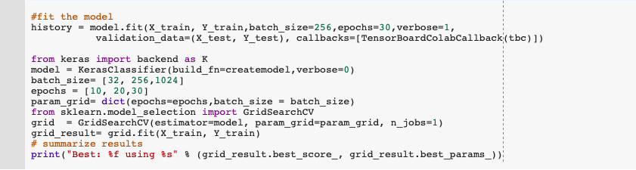

**Output:**

a) showing all categories in the dataset.

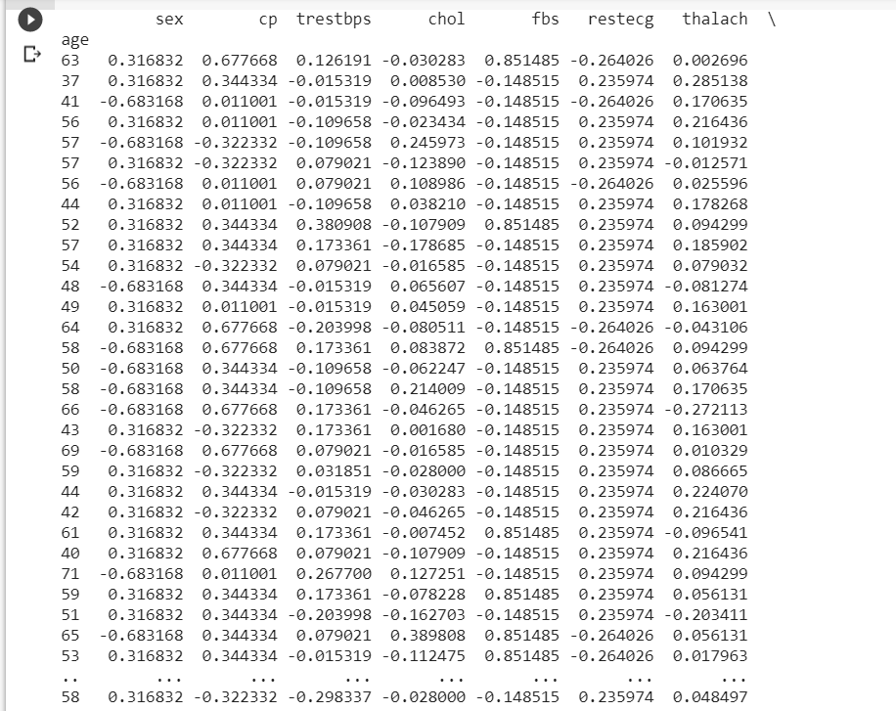

1. showing tensor board link and different epochs.

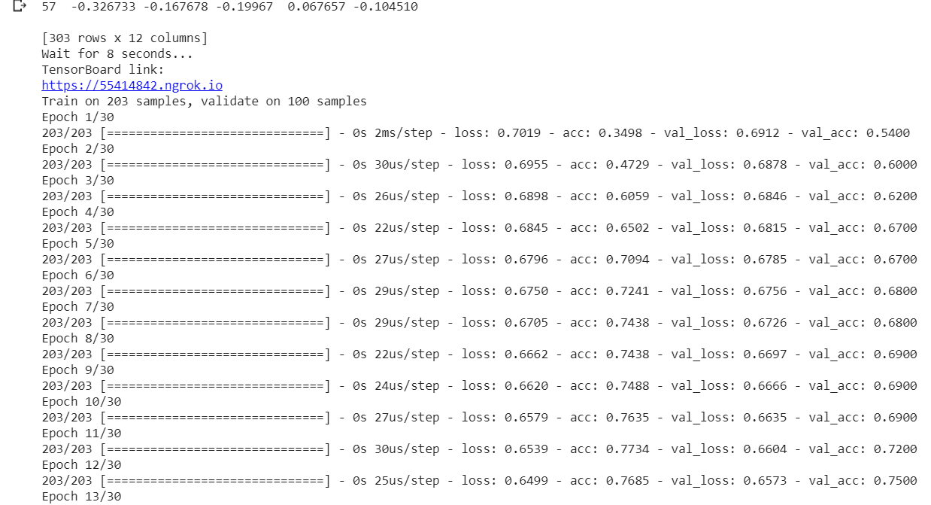

c)showing accuracy.

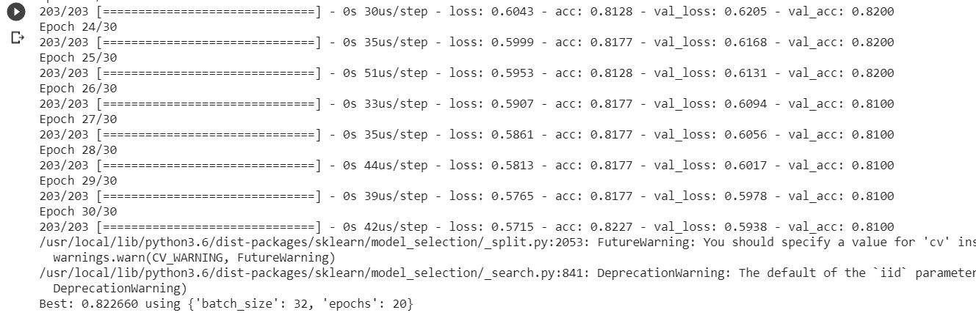

d) when Activation = sigmoid

batch size = 32

epochs = 20

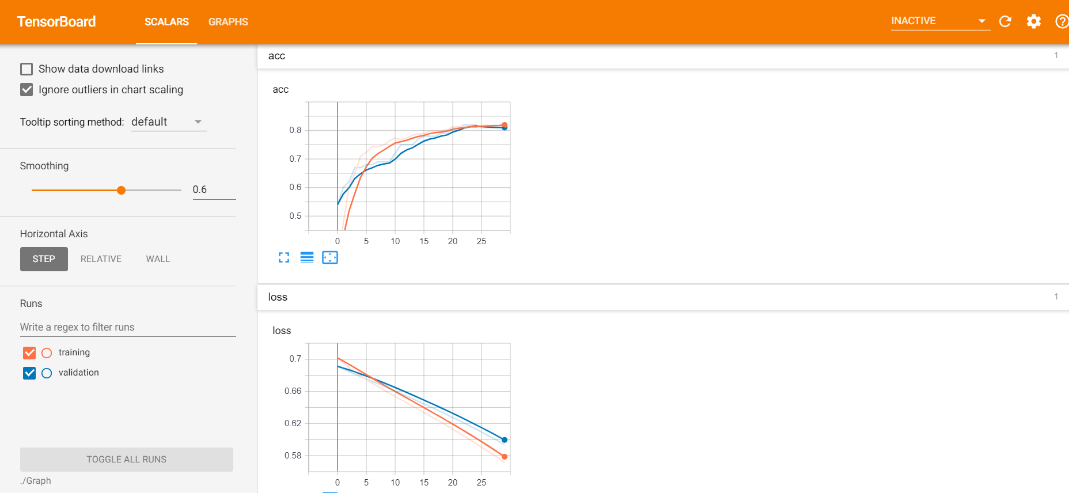

e) when activation = tanh

batch size = 32

epochs = 10

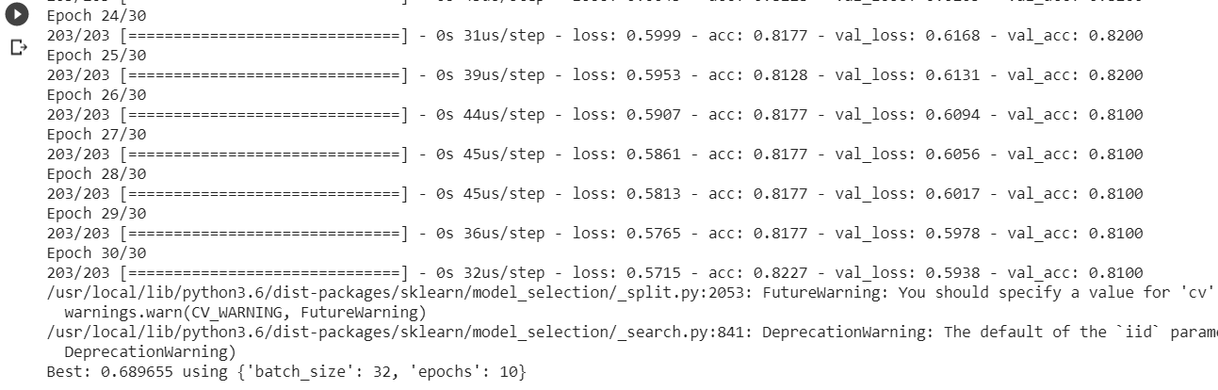

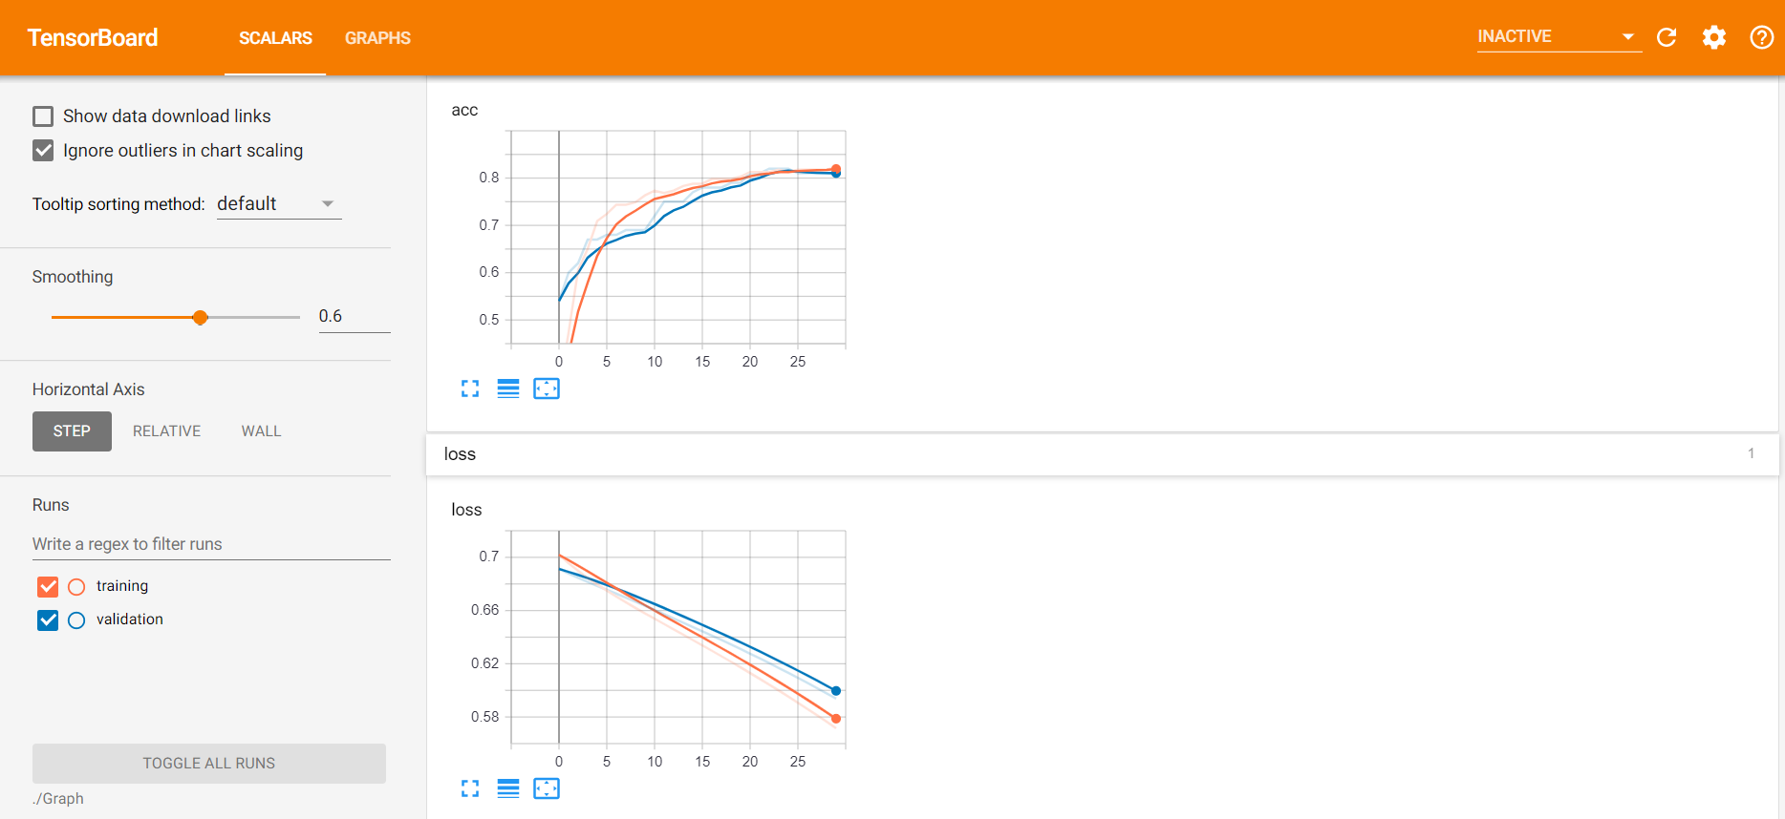

f) when activation = softplus.

Batch size = 256

Epochs = 50

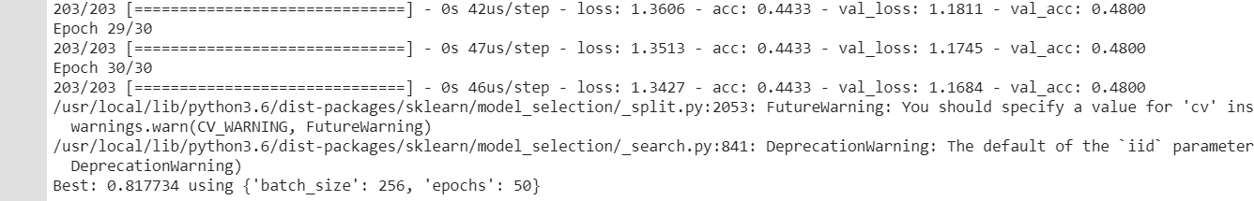

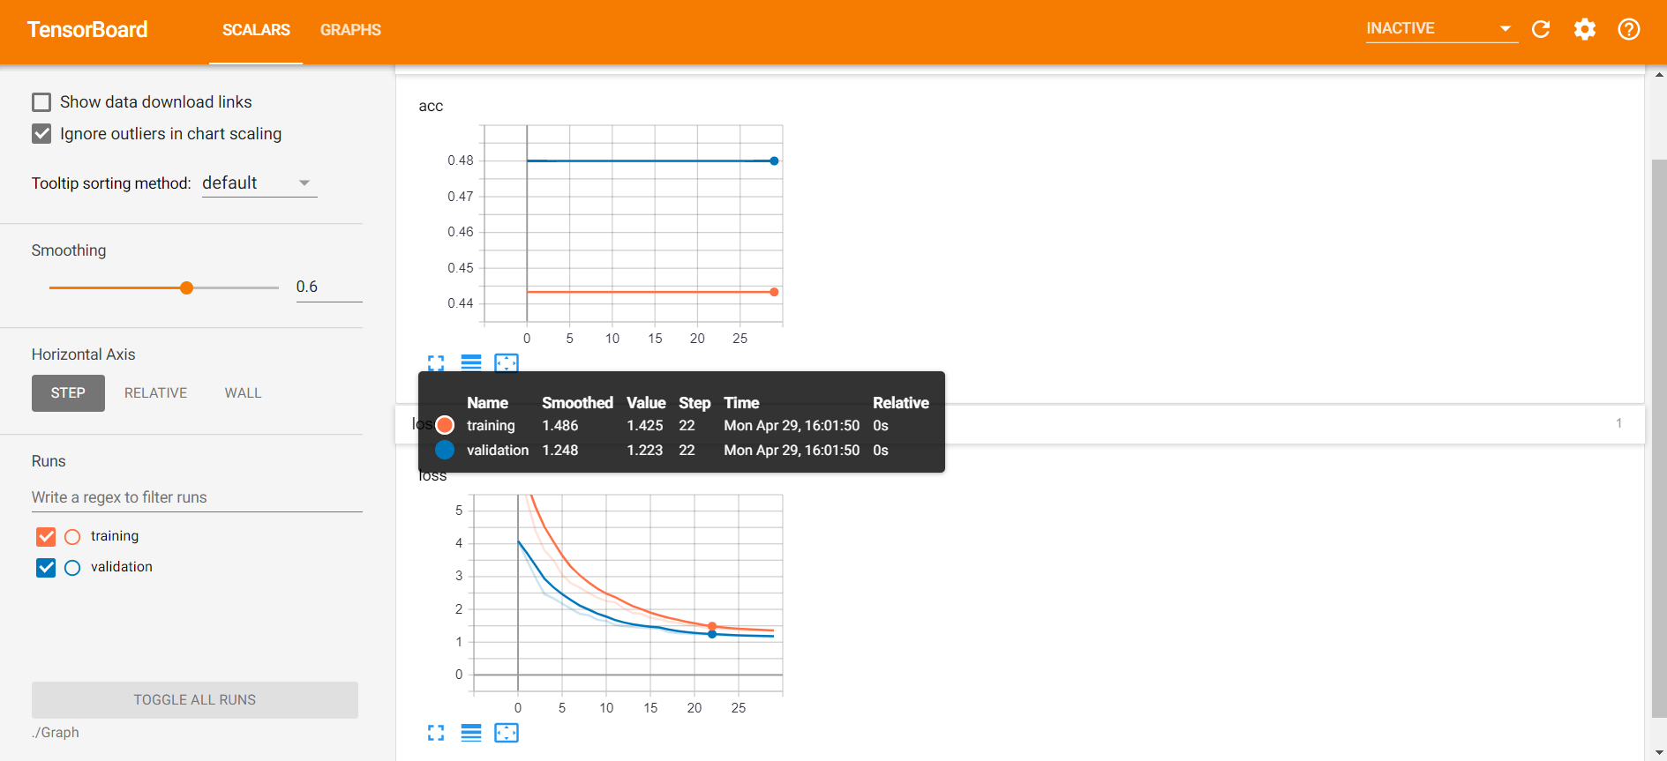

3.**Image classification with CNN model.**

**Approach:**

a) dataset = monkey species dataset

b) created sequential model and convolution layer is added.

c) model is fitted, and accuracy and loss are plotted.

**Workflow:**

a) load the dataset.



b) using image data generator, train and test generator are created. Also, a model is created to classify data using CNN classification.



c) plot the accuracy and losses.



**Output:**

1. Output showing train images and test images.

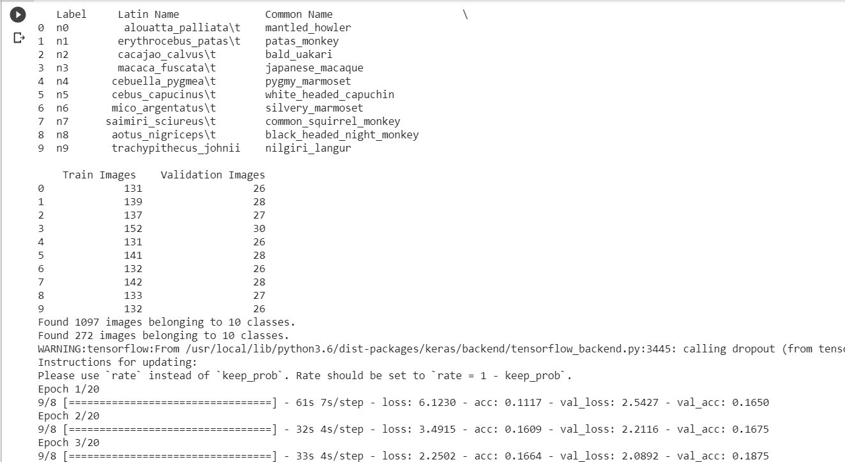

b) showing total params.

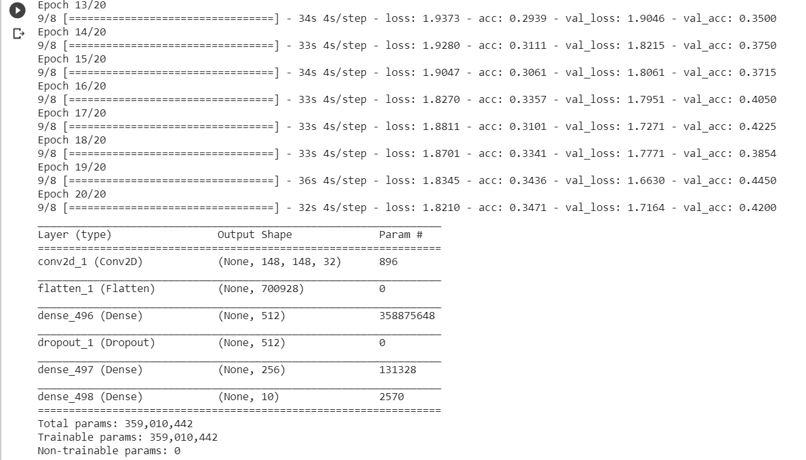

c)plotting the graph showing accuracy and losses.

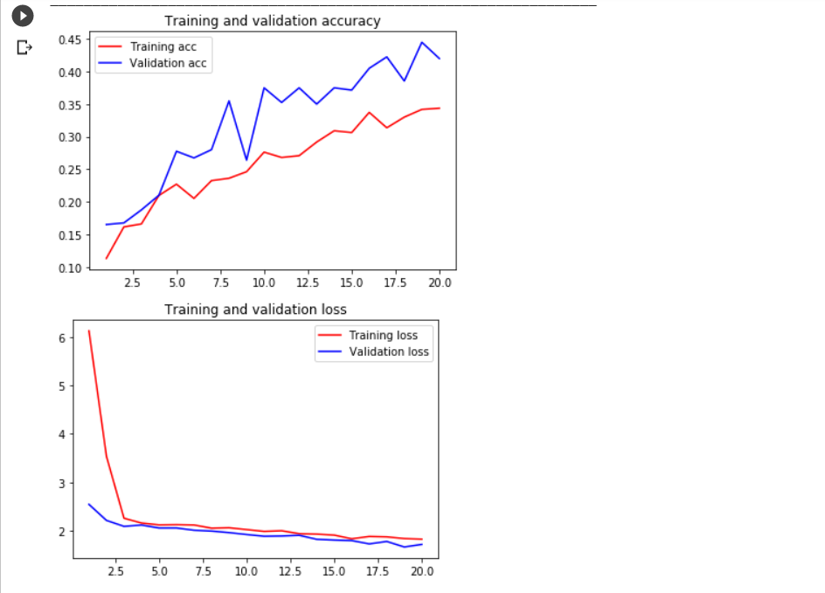

4**. Implementation of text classification on movie reviews dataset with CNN model.**

**Approach:**

a) used movies dataset.

b) sequential model is created

c)convolution layer is added.

**Workflow:**

a) Dataset is loaded.



1. Data is cleaned and a tokenizer is initialised.



c)sequential model is created using keras CNN and added convolution layers- input layer,dropout layer, maxpool layer, dense layer and finally fit the model.



**output:**

a)

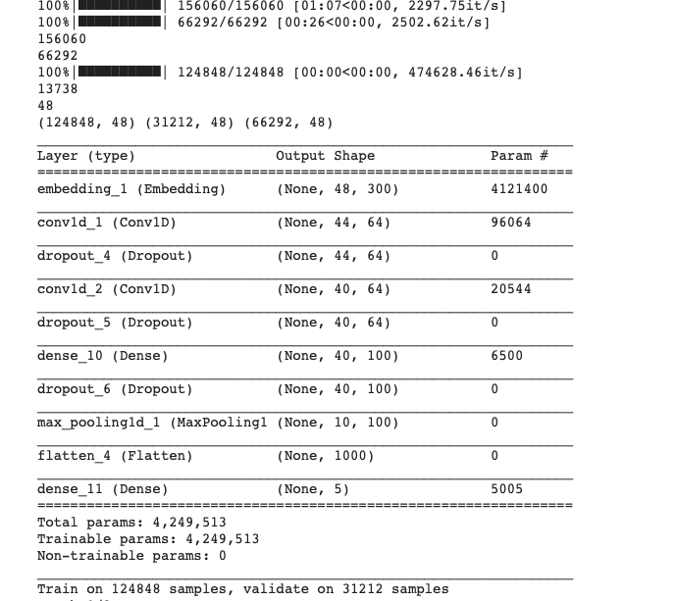

b) Accuracy



5)**Implementation of text classification on movies dataset using LSTM model.**

**Approach:**

a) movies dataset is used.

b) sequential model is created

c) LSTM layer is added.

**Workflow:**

a) movies data set is loaded and tokenized the dataset

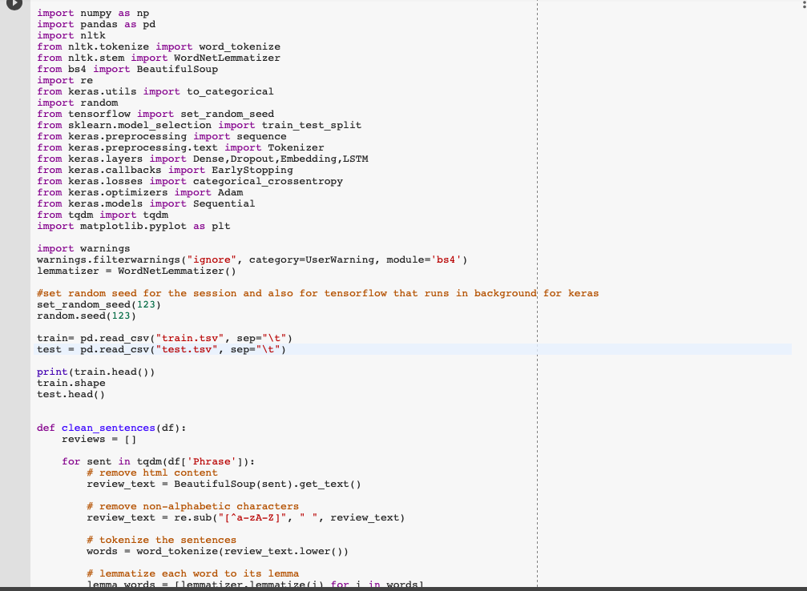

b) Data is cleaned, and a tokenizer is initialized and also LSTM network need all inputs of the same length.



c) Creating the sequential model using keras LSTM and fit the model.



**Output:**

a)total params



b) plot and accuracy



6) **Comparison between CNN and LSTM.**

Based on the graphs, we can say that LSTM has good validation consistency, also CNN has better accuracy, but it is not same and is not constant. LSTM works well when the dataset is huge, by changing different parameters we can observe that tanh gives better accuracy results and adam optimizer gives better results. Learning rate can also be changed to improve efficiency and accuracy.

Results:

